**DAY-3 PROGRAMS:-**

1. Write a java program for factorial using OOPS.

**Program:-**

import java.util.*;  
class FactusingOOP{  
 int n, fact=1, i, res;  
 void fact(){  
 Scanner s=new Scanner(System.*in*);  
 System.*out*.print("Enter the Number to find Factorial:");  
 n=s.nextInt();  
 for(i=1;i<=n;i++){  
 fact=fact*i;  
 }  
 res=fact;  
 }  
 void result(){  
 System.*out*.println("The factorial of Given Number "+n+" is "+res);  
 }  
}  
class FACT{  
 public static void main(String[] args){  
 FactusingOOP obj=new FactusingOOP();  
 obj.fact();  
 obj.result();  
 }  
}

**Output:-**

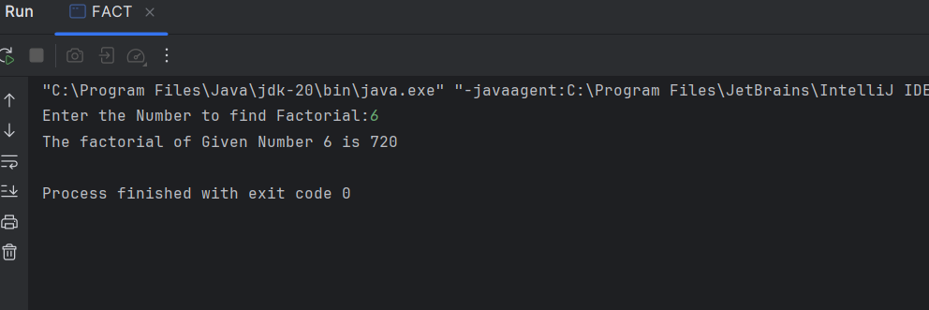

2. Write a java program for Simple Interest using OOPS Argument Passing.

**Program:-**

import java.util.*;

class SI{

    int p, t, r, intr=0;

    SI(){

        Scanner s=new Scanner(System.in);

        System.out.print("Enter Principal Amount:");

        p=s.nextInt();

        System.out.print("Enter Time Period:");

        t=s.nextInt();

        System.out.print("Enter the Rate of Interest:");

        r=s.nextInt();

    }

    void intr(){

        intr=(p*t*r)/100;

        System.out.println("The Simple Interest for Principal Amount "+p+" for Time Period "+t+" is : "+intr);

    }

    public static void main(String[] args){

        SI obj=new SI();

        obj.intr();

    }

}

**Output:-**

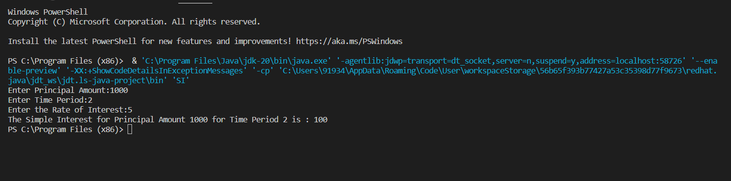

3. Write a java program that has a overload method. The first method should accept no arguments, the second method will accept a string and third method will accept a string and an integer. The first method should display the message “Welcome to java.” once. The second method should display the message “Welcome to Polymorphism.” twice. The third method should display “Welcome to Overloading.” thrice.

**Program:-**

import java.util.*;

class MethodOverloading{

    void arg(){

        System.out.print("Welcome to java!\n");

    }

    void arg(String a){

        for(int i=1;i<=2;i++){

            System.out.println(a);

        }

    }

    void arg(String b,int c)

    {

        for(int i=1;i<=3;i++){

            System.out.println(b);

        }

    }

    public static void main(String[] args){

        MethodOverloading t=new MethodOverloading();

        t.arg();

        t.arg("Welcome to Polymorphism!");

        t.arg("Welcome to Overloading!", 4);

    }

}

**Output:-**

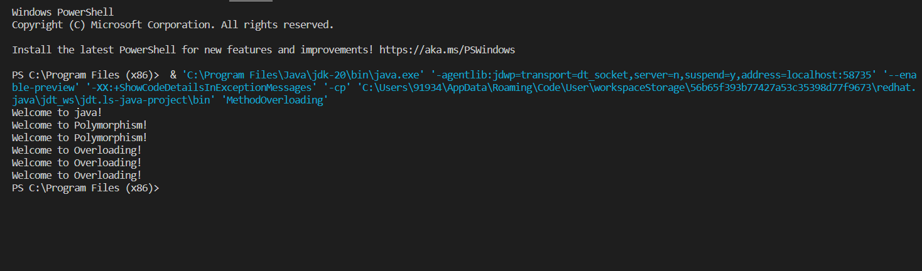

4. Write a java program for finding :

1. Area of circle :- pi*radius*radius
2. Volume of cylinder :- pi*radius*radius*height

Using Inheritance concept{especially:- Single Inheritance}

**Program:-**

import java.util.*;

class Circle{

    protected double area;

    private int r;

    void get(int a){

        r=a;

    }

    void cal(){

        area=3.14*r*r;

    }

}

class Cylinder extends Circle{

    protected double volume;

    private int h;

    void get1(int b){

        h=b;

    }

    void cal1(){

        volume=area*h;

    }

    void display(){

        System.out.println("The area of Circle is :"+area);

        System.out.println("The volume of Cylinder is: "+volume);

    }

}

class Inher{

    public static void main(String[] args){

        int x,y;

        Scanner s=new Scanner(System.in);

        System.out.print("Enter Radius:");

        x=s.nextInt();

        System.out.print("Enter Height:");

        y=s.nextInt();

        Cylinder obj=new Cylinder();

        obj.get(x);

        obj.cal();

        obj.get1(y);

        obj.cal1();

        obj.display();

    }

}

**Output:-**

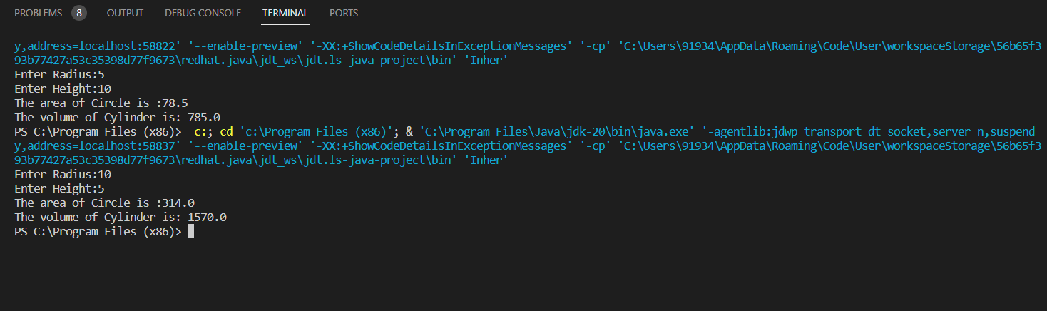

**ASSIGNMENT – 3:-**

1. Write a Java program to enter the marks of a student in four subjects. Then calculate the total and aggregate, and display the grade obtained by the student. If the student scores an aggregate greater than 75%, then the grade is Distinction. If the aggregate is 60>= and <75, then the grade is First Division. If the aggregate is 50 >= and <60, then the grade is Second Division. If the aggregate is 40>= and <50, then the grade is Third Division, else the grade is Fail. Using Multilevel inheritance concept.

Sample Input & Output:

Enter the marks in python: 90

Enter the marks in c programming: 91

Enter the marks in Mathematics: 92

Enter the marks in Physics: 93

Total= 366

Aggregate = 91.5

DISTINCTION

Test cases:

a) 18, 76,93,65

b) 73,78,79,75

c) 98,106,120,95

d) 96,73, -85,95

e) 78,59.8,76,79

**Program:-**

import java.util.*;  
class Students  
{  
 public double tot,agg,flag=0;  
 public double m1,m2,m3,m4;  
 void getm()  
 {  
 Scanner s=new Scanner(System.*in*);  
 System.*out*.println("Enter Marks of Student:");  
 m1=s.nextDouble();  
 m2=s.nextDouble();  
 m3=s.nextDouble();  
 m4=s.nextDouble();  
 }  
}  
class check extends Students  
{  
 void cal()  
 {  
 if(((m1<0 || m1>100)||(m2<0 || m2>100)||(m3<0 || m3>100)||(m4<0||m4>100)))  
 {  
 System.*out*.println("Enter proper marks");  
 }  
 else  
 {  
 tot=m1+m2+m3+m4;  
 System.*out*.println("total marks:"+tot);  
 agg=tot/4;  
 System.*out*.println("Avarage:"+agg);  
 flag=1;  
 }  
 }  
}  
class grades extends check  
{  
 void dis()  
 {  
 if(flag==1)  
 {  
 if(agg>75)  
 {  
 System.*out*.println("Distinction");  
 }  
 else if(agg>=60 && agg<75)  
 {  
 System.*out*.println("First Divison");  
 }  
 else if(agg>=50 && agg<60)  
 {  
 System.*out*.println("Second Divison");  
 }  
 else if(agg>=40 && agg<50)  
 {  
 System.*out*.println("Third Divison");  
 }  
 else  
 {  
 System.*out*.println("Fail");  
 }  
 }  
 else  
 {  
 System.*out*.println("The Marks Range is 0-100");  
 }  
 }  
}  
class out extends grades  
{  
 public static void main(String args[])  
 {  
 out o=new out();  
 o.getm();  
 o.cal();  
 o.dis();  
 }  
}

**Output:-**

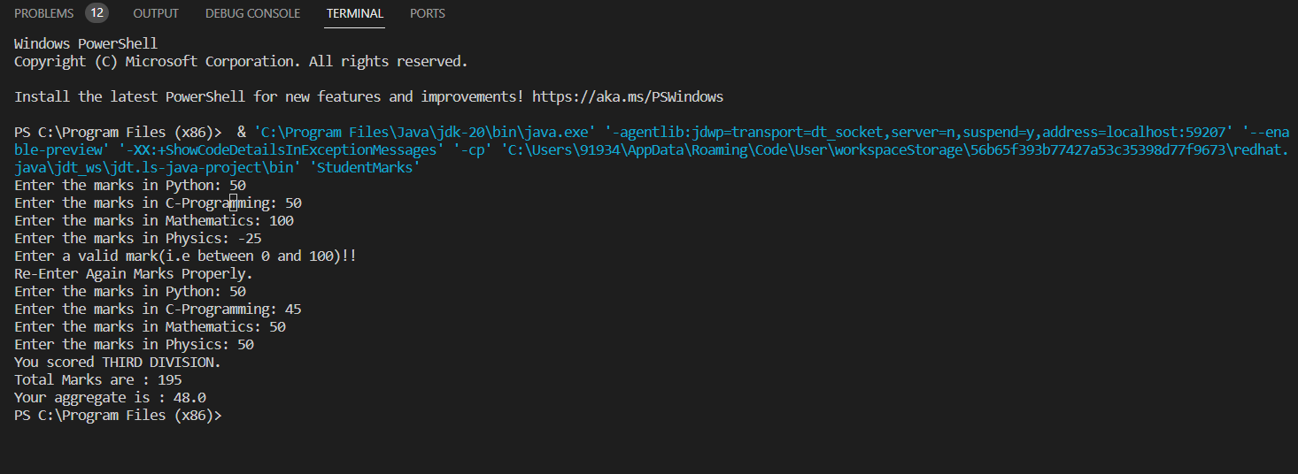

2. Write a Java program for the area of the circle, the volume of the cylinder, and the volume of the cone. Using Multilevel inheritance concept.

Area of Circle: pi × radius2

Volume of cylinder: pi × radius2 × height

Volume of cone: (1/3) × pi × radius2 × height

**Program:-**

import java.util.*;  
class Arae2 {  
 public double area;  
 public double h, r;  
  
 void cal() {  
 Scanner s = new Scanner(System.*in*);  
 System.*out*.println("Enter the height and radius:");  
 h = s.nextDouble();  
 r = s.nextDouble();  
 area = 3.14 * r * r;  
 System.*out*.println("Area of circle:" + area);  
 }  
}  
  
 class cy extends Arae2 {  
 public double cyvol;  
  
 void cal2() {  
 cyvol = 3.14 * r * r * h;  
 System.*out*.println("volume of cylinder:" + cyvol);  
 }  
 }  
  
 class cone extends cy {  
 public double covol;  
 void cal3()  
  
 {  
 covol = r * r * h / 3;  
 System.*out*.println("volume of cone:" + covol);  
 }  
 }  
  
 class dis  
 {  
 public static void main(String []arg)  
 {  
 cone obj =new cone();  
 obj.cal();  
 obj.cal2();  
 obj.cal3();  
 }  
 }

**Output:-**

